**Summary:**

**Nancy Lazar (Global Economics):**

* The great Handoff :
  + Successful handoff from the public to the private sector:
* GOVT spending declines, as business confidence/spending surges
* Monetary Stimulus fading as banks ease, since feds has stopped cutting rates
  + Reflation trade is over, see it in the markets:
* Yields from treasury is signaling that the trade is over and this is good with this being better for longer term growth
* Lower commodities signals lower inflation, good for economy
* Corporate spreads signal sustainable growth
  + CPI will peak will flow clearly in 2022:
* V-bound morphing into sustainable expansion
* US CPI is peaking and likely not to slow to 2.5% until 2022
  + CAPEx is underappreciated, major driver of jobs and productive, big factor in keeping inflation low :
* Jobs likely to soar and labor force participation rise
* Most hurt sectors are going to contribute to the growth (transportation, leisure)
* The unemployment rate is likely to drop to 3.5% as we see wages accelerate.
* Fiscal cliff
* Transfer Payments falling, but private cash/compensation rising
* Tech capex soared, and now industrial capex accelerating
* Housing up big in 1H and likely to see House prices slow in 2H
  + Global Reflation trade is over :
* Sustainable Growth ahead
* EM tightens
* Short rates have stabilized

**Victor Cossel (TMT outlook):**

* Tech: Cycling into tough compares and mean reversion
* Negative bias remains in 1H underperformance and 2H compares
* Equity Risk Premium really low as cyclical GCP improves and is looking like it will lower the premium which is an offset until it isn't
* EPS yields suggest high expectations and the price limiting the incremental beat and rise
* De-rating of the tech multiple is likely to happen as the fed balance pass their Y/Y peak
* ECON sees a handoff from COVID beneficiaries alike TECH
* STRAT thinks it is too early for growth, big cap skewed tech sector
* Tech bottomed early 2019, soar through 2020, making it hard for compares in the back half of 2021
* Revert could be incoming as TECH pulled forward after an aberrational upside demand shock in 2020
* Underappreciated risk:
* China's inward pivot
* Inflationary cost of compute
* Supply Chain decentralization
* Bullish bias for GOOGL, FB, INTC, IGV > SMH

**Carter Worth (Technicals):**

* Technical Analysis:
* Favor Growth vs. Value
* Favor large vs Small cap
* Favor “rested Champions vs. startups and has-beens
* 10 yields at the right level or “where it belongs
* US dollar judged to be just about “where it belongs
* Gold judge to be an important hedge for all portfolios
* Overall equity market “good/intact’ only so long as Tech, Growth & large Cap stocks are good and intact.

**Danny Kirsch & George Lam (Options):**

* Options Strategy & Trading Outlook
* Option ideas for2H 2021:
* Upside: SPX Ratio Risky
* Tapering trade: Sell TLT call to buy put spread
* Hedges: EEM, EWT, SMH, and LQD put Spreads
* Trading Meme Stonks (dodge coin, Gamestop, AMC, etc.)
* Positioning for lower volatility:

1. Overwrite large caps stocks
2. VIX puts

* Record Option Volumes:
* Single stock options listing at highs
* Record open interest
* Shift to short-dated expires
* Rise of retail options trading (GME and AMC eps.)
* S&P 500 by year-end: what's priced in?
* Street estimates range from -12% to +7% (kantro is at 4500, +4.7%)
* Take Advantage of high spx skew
* High skew means far OTM put implied vols are high relative to nearer to the money puts and calls
* The current environment of low vol and high skew = cheap SPX put spreads
* 5% OTM put implied vols are high relative to 5% OTM implied vols
* Currently, you can sell one SPX 2M 5% OTM put to fund ~5x 5% OTM calls
* Fading memes:
* Buy inexpensive ratio put spreads to fade the stocks and elevated volatility of crowded short
* AMC:

1. Buy 1x August 20 puts
2. Sell 3x August 13 puts
3. Even money, (ref 46.19)

* As stocks correct, we would expect implied volatility to drop towards the lows
* Can do similar trades at times when stocks rally a lot and put little change in price

**Andy Laperriere & Don Schneider (US policy):**

* Difficult Path Forward For The Biden Agenda
* The outlook is murky because Biden failed to meet the Congresses slim margins
* The bipartisan deal and then the reconciliation package passed down the road
* 1.5 trillion in spending over 10 years and 1 trillion in new taxes if the reconciliation bill becomes law. Around November
* Two tracks were not Biden plan, forced on him:
* Biden did not propose a bipartisan econ agenda, and He walked away from those negotiations
* Manchin and Sinema are driving the bus, the best plan forward seems for him to Approve BIF first, then work towards his agenda.

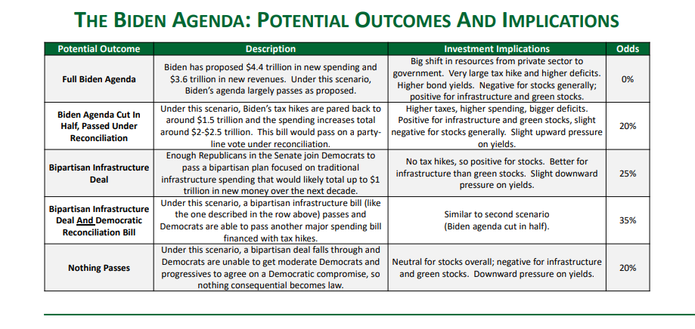

* Other things to worry about:
* Prescription Drugs / Health Care
* Labor
* Antitrust

**Jan Stuart, Thomas Marchetti & Chris Kettenmann (Energy):**

* Investing Across the Spectrum of Energy:
* Decarbonizing the Power Sector: Will we still need fossil fuels?
* Seems like the Power generation Industry is the furthest ahead in decarbonization
* Wind and Solar fill the gap in a ‘no new gas’ scenario
* Emission targets are achievable, but the reliability of the grid requires dispatchable sources (gas/nuclear)
* The pace of our renewables build-out is accelerating:
  + Renewable Developments ‘on Pace’
  + Policy Support Should Accelerate Adoption and Reduce Costs, while reliability challenges in intermittency and seasonality remain
  + Investments in energy storage still need exploration
* The Road to Electrification: How fast are EVs ‘electrifying’ transportation?
* Major auto firms commit to 100% Electrification, will consumers?
* Faster EV Adoption Rates in Major Auto Regions could leave smaller economies in the dust
* Decarbonizing Fossil Fuels: Really?
* Commitment to Mitigation and Abatement
* Disinvestment isn't the way to solve Economy-Wide Problems, it requires economic wide solutions
* Investing: How to think about returns on investments through the Energy Transition … … in the second half of this year, opportunities in oil and gas should emerge as well
* Modeling more demand growth than others, and seeking global demand in the next decade or so
* Oil demand is north of 100 mb/d, making the Opec management unpredictable
* The energy transition is not going at the speed needed to phase out oil or gas yet
* Short-cycle investments will be needed to grow the shale et al. by >1 mb/d per annum through at least 2025

**Roberto Perli & Benson Durham (global policy):**

* Treasury Yields In The Second Half: Torn Between Fed Policy Expectations And Sound Fundamental;
* A lower expected neutral rate
* A neutral rate sets an effective limit on how much the Fed can hike without harming the economy.
* All of that decline is in the nominal (inflation expectations) component.
* Lower Inflation Expectations
* Market inflation rose back to pre-Covid levels, as the market started to believe in the feds new framework
* Lowering long rates and a flatter yield curve
* Higher expected fed funds rates in the near term pushed up the short end of the curve; lower expected funds rates thereafter held down the long end. Result: Flatter curve.
* Fed leadership will push back against the market interpretation

**Michael Kantrowitz (strategy)**:

* A Balanced Approach In The Second Half
* Well past the best days for high beta and low quality
* Moving past the prime period for the value
* Less alpha in factors when in the middle of a cycle
* Growth Unlikely to sustain our performance in H2
* It is way too early for defense
* The spike inflation is also not likely to weigh on the cycle until 2022

